**App Service Plan – Cost Difference.**

**Subscription** - Digital_BU_CTO_MTH-CyFast.

**Project** – CyFast.

**Standard Service Plan**:

The Standard service plan is designed for running production workloads. Pricing is based on the size and number of instances you run. Built-in network load balancing support automatically distributes traffic across instances. The Standard plan includes auto scale that can automatically adjust the number of virtual machine instances running to match your traffic needs.

**Premium v2 Service Plan**:

The Premium service plan is designed to provide enhanced performance for production apps. The upgraded Premium plan, Premium v2, features Dv2-series VMs with faster processors, SSD storage and double memory-to-core ratio compared to Standard. The new Premium plan also supports higher scale via increased instance count while still providing all the advanced capabilities found in the Standard plan

Below example shows the exact cost difference.

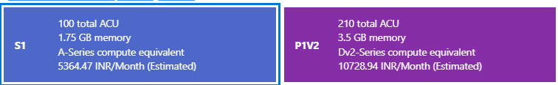

* Per month - 5,364.47 INR. Per month - 10,728.94 INR.
* Per year - 64,373.64 INR. Per year - 1,28,747.28 INR.
* Difference per month - 5,364.47 INR. Difference per year - 64,373.64 INR.